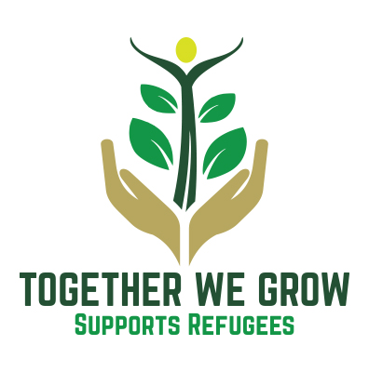

Together We Grow Volunteer Policy

1. Introduction
Together We Grow is a charity. Our objectives are;

(1) To promote equality and diversity for the public benefit for people displaced and seeking asylum or refugees settling in the neighbouring Boroughs of Calderdale and Rochdale and wishing to integrate with the inhabitants of these Boroughs.
(2) To promote social inclusion for the public benefit by preventing people in the Boroughs of Calderdale and Rochdale from becoming socially excluded, and relieving the needs of those people within the Boroughs of Calderdale and Rochdale who are socially excluded by reason of their refugee or asylum seeker status and assisting them to integrate into society.'
We recognise the fundamental value that volunteers bring to our organisation and those who use our services, without whom the organisation could not function.

Within Together We Grow volunteers are involved in:
- The Board of Trustees
- Delivery of all activities with our members.
- Financial management

Together We Grow aims to have a reciprocal and mutually beneficial relationship with our volunteers; with their involvement informing and developing our work, and our work enabling individuals to learn skills and achieve personal development through their volunteering.

The involvement of volunteers will be guided by the following principles of good practice:
- The tasks to be performed by volunteers will be clearly defined, so that everyone is sure of their respective roles and responsibilities;
- The organisation will comply with the GDPR in the use of data held on all volunteers;
- Training opportunities will be offered to enable volunteers to develop their own potential
- All costs eg travel and childcare will be reimbursed to ensure Together We Grow is open to all
- Volunteers will be actively encouraged from the communities we serve, specifically people seeking asylum and refugees

2. The Purpose of this Policy
By adopting this policy Together We Grow aims to:
- highlight and acknowledge the value of the contribution made by volunteers;
- reflect the purpose, values, standards and strategies of the organisation in its approach to involving volunteers;
- recognise the respective roles, rights and responsibilities of volunteers;
- confirm this organisation’s commitment to involving volunteers in its work;
- establish clear principles for the involvement of volunteers; and
- ensure the ongoing quality of both the volunteering opportunities on offer and the work carried out by our volunteers;

3. Recruitment and Selection

Together We Grow will adhere to its Equal Opportunities policy when recruiting and selecting volunteers.

4. Support and Supervision

Once placed, we will expect volunteers to comply with existing policies and procedures. All volunteers are covered under Together We Grow’s Public Liability Insurance.

All core volunteers (those who are involved in regular events and small group / individual work) will have an induction to their volunteering which will involve an overview of the relevant policies and procedures. These volunteers will be required to undertake a basic level DBS check

Volunteers will be able to claim all costs associated with attending events / meetings for Together We Grow eg transport, childcare and where appropriate refreshments

Volunteers can access learning and development opportunities which are relevant to their volunteering role throughout their time with Together We Grow. Opportunities for Learning and Development will be circulated to all volunteers.

5 Problem Solving
Where a concern is highlighted – either by a volunteer or about a volunteer, this will be dealt with using the organisation’s relevant policy.

6 Responsibility
Overall responsibility for the implementation, monitoring and review of the policy and procedures lies with the Chair of Together We Grow.

September 2022
Review September 2024

